Cloud Computing

**Name:** Jerusha Angel K

**Register No**: 727721EUCS049

Day-10

**Day 10_DevOps_CE1**

**Content Description:**

Create an EC2 instance with the following requirements.

* Install and run the Docker engine on the EC2 instance.
* Download a default docker image from the docker hub.
* Create a docker container with the downloaded image.
* Make sure the container should run a simple website.

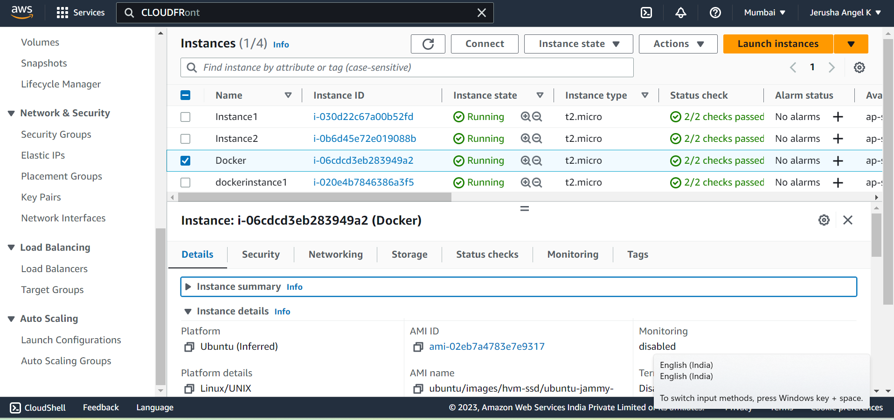

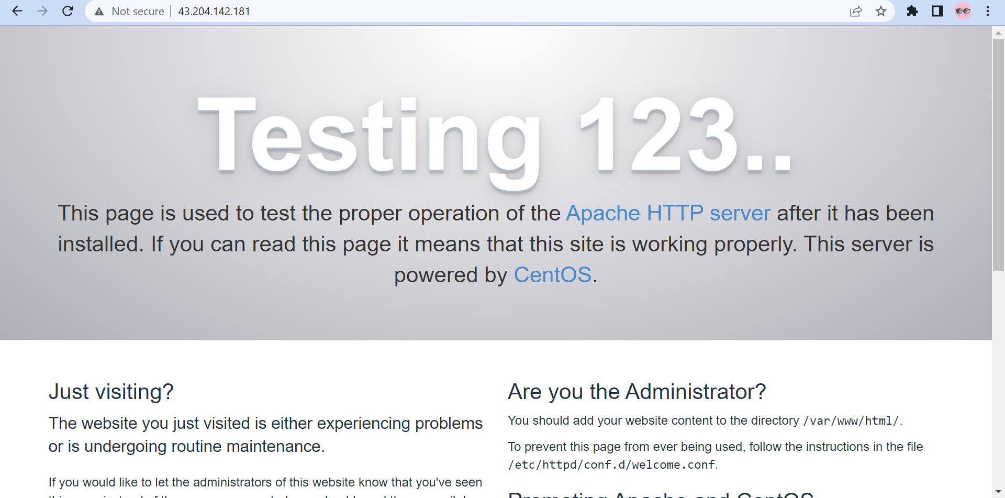

**Day 10_DevOps_CE2**

**Content Description:**

Store a Docker image in the AWS ECR with the following requirements

* Write a dockerfile for creating a docker image from the source of ‘centos’.
* Make a webservice for the new docker image by using the docker file.
* Create a docker container from the created image and make it run in the host.
* Push the created docker image in to a Public Repository of the Amazon ECR

